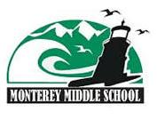
Monterey Middle School
Ocean Studies Classroom
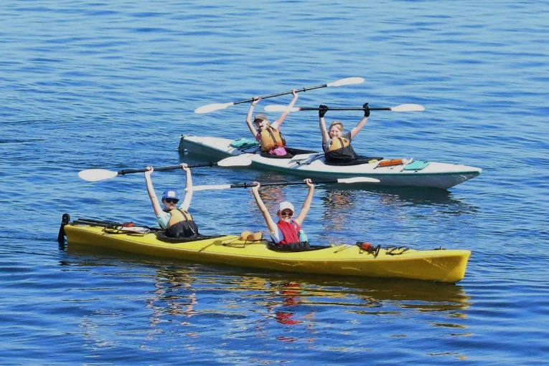

Imagine! Your Grade 7 year with scheduled Sea Kayaking trips in Oak Bay.

We are looking for students who want to spend more time outdoors. Students in Ocean Studies will be expected to be collaborative learners who can thrive in a team environment. Students should have a strong affinity for learning outside the regular classroom and should be comfortable in a marine environment, either on or off the water. A sense of personal responsibility is essential, especially given the nature and frequency of off-campus activities. Also, we are looking for supportive families who appreciate that their child will embark on an adventurous school year, using the natural environment as an extension of the classroom.

Is this the right fit for you? Are you interested?!!!
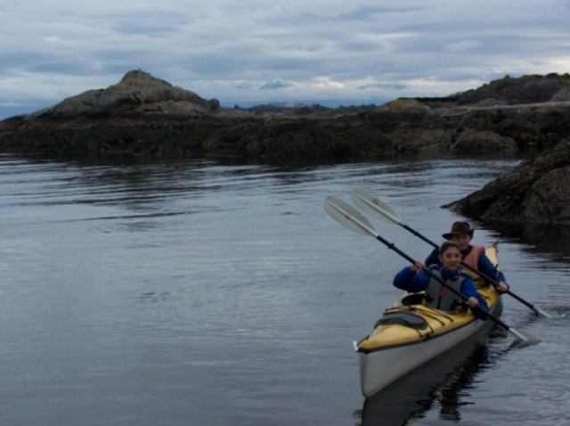
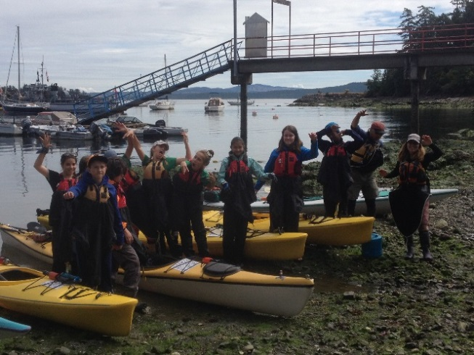
If so, be sure to ask your parents to email Monterey’s principal – Mr. Andrews at kandrews@sd61.bc.ca – with a class placement request for the 2017-18 school year for you to be in the grade 7 “Ocean Studies” classroom with Mr. Brown. Also, your parents must submit a deposit of $150 by cheque made out to “Monterey Middle School” (with “Ocean Studies deposit” in the subject/memo line) by April 28, 2017.

Turn Over for further details. . .

Costs & Payment Information: The Ocean Studies classroom offers many fieldtrip experiences, including various sea kayaking excursions which culminate in an overnight sea kayak/camping trip! Like all classes, we must charge on a cost-recovery basis for the cost of these enriched activities. For the experiences planned for Ocean Studies in the 2017-18 school year, we estimate the costs will be between $475 and $575 in total. We require a deposit of $150 by April 28th, 2017, along with your class placement request, and the balance due will be finalized in early September with payment expected by September 30, 2017. For both the deposit and the balance, an extension will be considered upon request for families in financial need of a payment plan by installments. Also, a subsidized rate or exemption from payment may be possible due to financial need. Please contact the school principal to discuss your needs and options if financial assistance is necessary for your family. Like all classes, students placed in Mr. Brown’s class (with its emphasis on “Ocean Studies”) will find out their class placement during the first week of school (see section below), and deposits will be refunded to those not placed in this class. Please note that students (and their parents) who have requested Ocean Studies and paid their deposit have made a commitment to be in this class for the school year. Due to the class size and make-up of other classes, it may not be possible to withdraw from Ocean Studies and transfer into another class. In the unlikely circumstance that a student is able to withdraw from Ocean Studies prior to or during the school year, refunds will only be issued (on a pro-rated basis minus your deposit) if the school admits sufficient replacement students to cover the remaining costs.

Class Placement Requests: Requests to be in Mr. Brown’s advisory class with its particular focus on “Ocean Studies” must be made directly to Principal Andrews (and deposit submitted to the office). These will be treated in a similar manner to other class placement requests. Like all class placements, requests will be considered with a view to creating the most educationally sound and balanced classes possible throughout Monterey. While we will consider your child’s interests, there will be situations where it will not be possible to accommodate all interested students because of class size limitations and the many factors involved in trying to build the best possible educational experience for all students. Among the factors we consider are: peer relationships; children’s social, emotional, physical, and intellectual needs; balancing the number of boys and girls in a class; providing enriched opportunities and remedial support; balancing numbers of students between classes; and trying to create the most advantageous overall educational setting possible for all students at our school.

